2026 Agricultural Day Project

Children who have calves, lambs, goats and chickens DO NOT have to complete this project as time during Term 3 should be spent working on and caring for your animals.

All other children from Year 4 up who do not have an animal for Agricultural Day are expected to complete the following project. Year 3 students may complete the project if they like. This is part of your homework for Term 3.

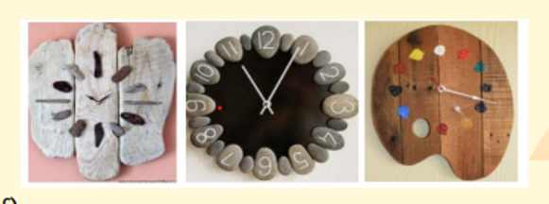
Any queries should be directed to teachers or Mrs Glasgow early – don’t leave the project until the last minute! Mum and Dad may help you but it must be your own work. (The judges disqualify any projects they think are done by adults.)

OUTDOOR CLOCK
Use of Natural or Recycled Materials or a mixture of each

Part One:
Research and design a plan for what you think would be a great outdoor clock that could be placed in your family garden at home.
Think about the materials you will use (either natural or recycled - or a mixture of both.) Is your selection of materials going to be reasonably weatherproof? Is it going to be strong enough (without breaking if the wind is strong?)

You need to consider
• The shape and size of your clock (no bigger than 60cm x 60cm (The judges measure the project!!!)
- Your clock does not require a mechanism to work - it is for display only.
• Where you will place it at home – e.g. on the wall, attached to a pole in the vegetable
garden or flower garden
- Explain why you have made these decisions.

This information needs to be presented in an attractive and accurate way. You can choose the means of presentation e.g. chart, booklet, poster, powerpoint, brochure, mobile, etc. Include photos of you working through the steps in making your outdoor clock as well. This must be handed in with your clock and will be considered by the judges alongside your finished outdoor clock.

Part Two
Collect the natural or recycled materials that you have decided to use for your outdoor clock.
Complete your design plan and make your clock.
The clock should be no bigger than 60cm square (but may be smaller.)

Part Three
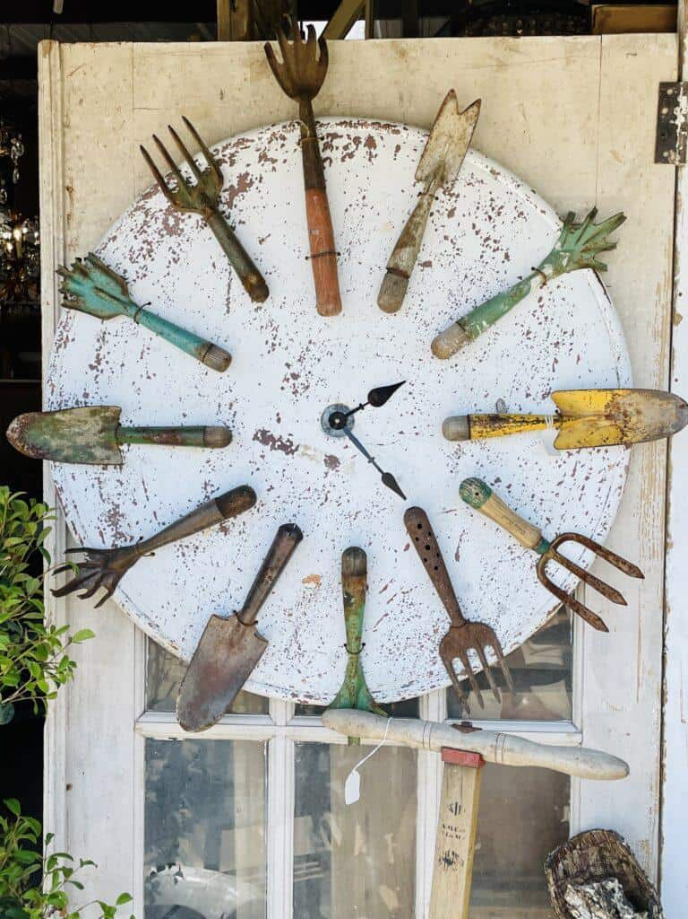
Bring your finished clock and brief to school during the week before AG day. No later than Thursday 24 September as this will help us set up for judging on Friday.
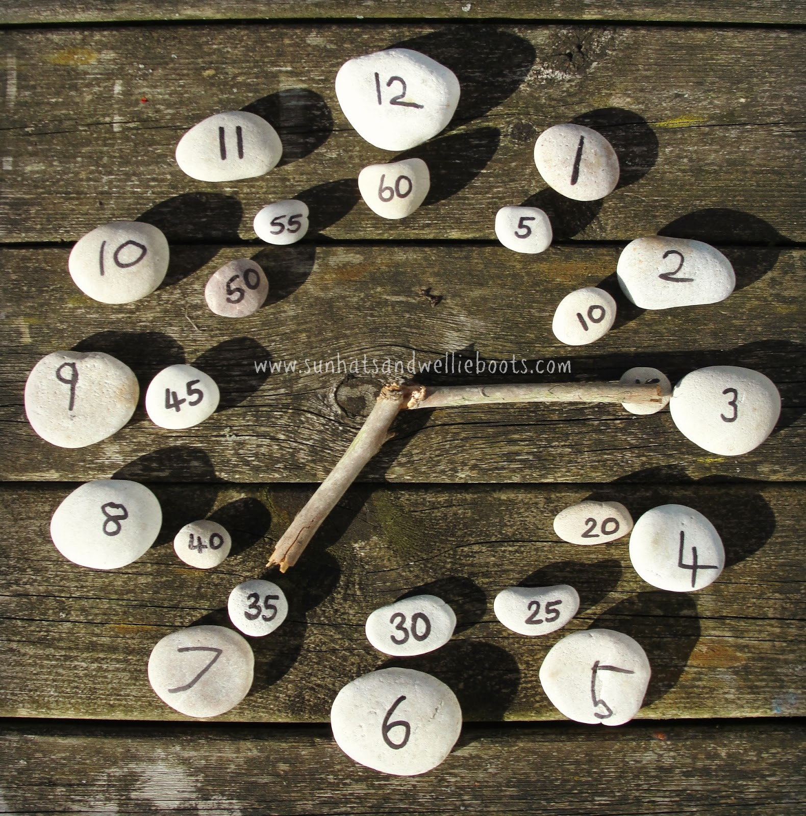
Have Fun!

